**Section 2–6B: Families of Functions**

**(Reflections and Vertical Stretches/Compressions)**

A **reflection** flips the graph of a function across a line, such as the *x*- or *y*-axis. Each point on the graph of the reflected function is the same distance from the line of reflection as its corresponding point on the graph of the original function.

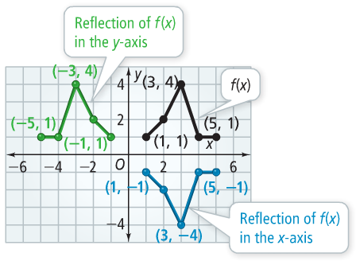

When you reflect a graph in the *y*-axis, the *x*-values change signs and the *y*-values stay the same.

When you reflect a graph in the *x*-axis, the *x*-values stay the same and the *y*-values change signs.

For a function $f(x)$, the reflection in the *y*-axis is $f(-x)$ and the reflection in the *x*-axis is $–f(x)$.

**Example 1: Reflection in the *y*-Axis**

**A.** Graph: $y=-x$**B.** Graph: $y=2x+3$ and $y=-2x+3$

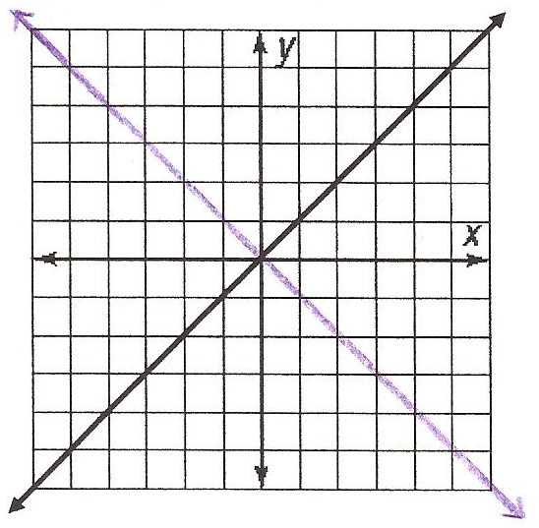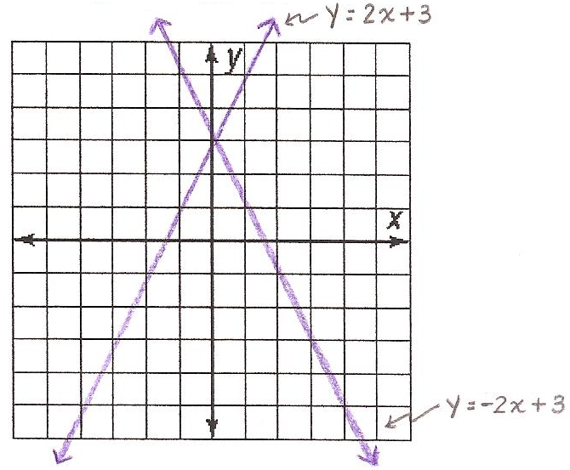

**Example 2: Reflecting a Function Algebraically (Pg. 101 – Problem 3)**

Let $g(x)$ be the reflection of $f\left(x\right)=3x+3$ in the *y*-axis. What is a function rule for $g(x)$?

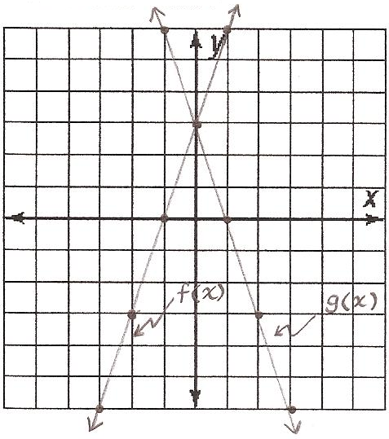

$f\left(x\right)=3x+3$

$g\left(x\right)=f(-x)$

$g\left(x\right)=3\left(-x\right)+3$

$g\left(x\right)=-3x+3$

**Example 3: Reflection in the *x*-Axis**

**A.** Graph: $y=2x+3$ and $y=-2x-3$**B.** Graph: $y=x^{2}$ and $y=-x^{2}$

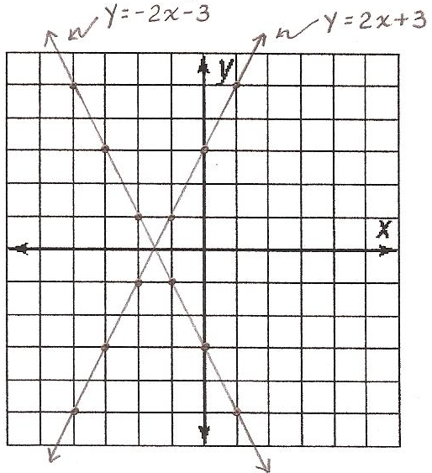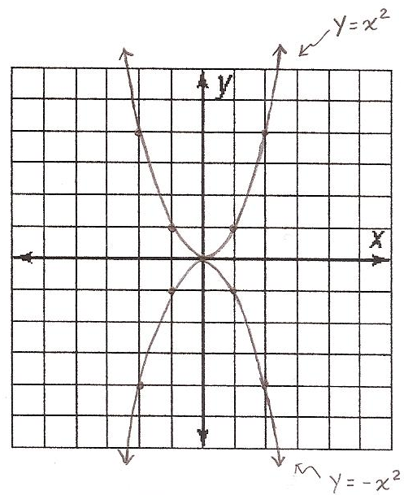

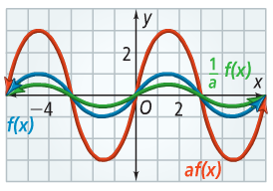

A **vertical stretch** multiplies all *y*-values of a function by the same factor greater than 1. A **vertical compression** reduces all *y*-values of a function by the same factor between 0 and 1. For a function $f(x)$ and a constant $a$, $y=af(x)$ is a vertical stretch when $a>1$ and a vertical compression when $0<\frac{1}{a}<1$.

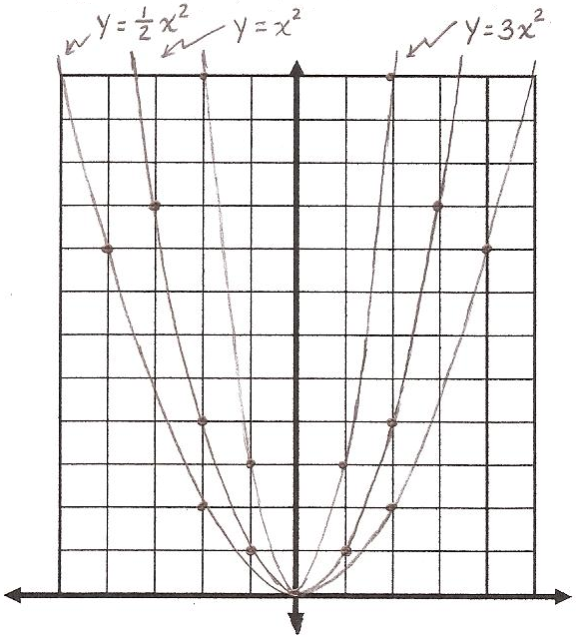**Example 4: Stretching and Compressing a Function**

Graph: $y=x^{2}$, $y=3x^{2}$, and $y=\frac{1}{2}x^{2}$

**Looking Ahead:**

You can only stretch or compress a function, if and only if, the degree of the polynomial function is greater than 1. For example, you can stretch or compress $y=x^{2}$ and not $y=x$.

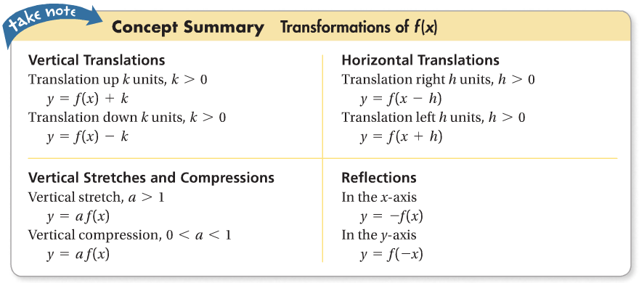

**Example 5: Combining Transformations**

The graph of $g(x)$ is the graph of $f\left(x\right)=4x$ compressed vertically by the factor $\frac{1}{2}$ and then reflected in the *y*-axis. What is a function rule for $g(x)$?

$\frac{1}{2}\left(4x\right)=2x$ Compress $f(x)$.

$2\left(-x\right)=-2x$ Reflect the new function in the *y*-axis.

The function rule is $g\left(x\right)=-2x$.